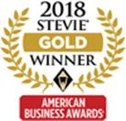Better Air North America, LLC was named the winner of a Gold Stevie® Award in the “Company of the Year – Health Products and Services – Small” category at the 16th Annual American Business Awards®. BetterAir was recognized for its Enviro-Biotics™ line of probiotics that improves air quality and prolongs the cleanliness of hard surfaces. Enviro-Biotics create an indoor microbial balance, combating Sick Building Syndrome by replenishing the necessary load of beneficial bacteria. The company’s devices offer an automatic solution for a range of public and private spaces—from 200 square feet to up to 45,000 square feet—including households, gyms, spas, health care facilities, hotels, schools and transportation.

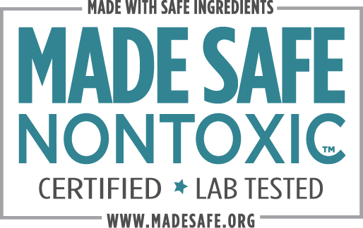

MADE SAFE®is America’s first nontoxic seal for products we use every day, from baby to personal care to household and beyond. We certify that products you use on your body, with your family, and in your home are made with safe ingredients not known or suspected to harm human health.

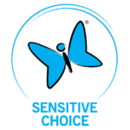

Sensitive Choice is a community service program created by the National Asthma Council Australia for all of us who want to breathe purer, cleaner, fresher air and reduce asthma and allergic reactions.

While the Sensitive Choice program and the products they approve do not claim to offer cures or treatment for such conditions, they conscientiously strive to help cleanse and purify the personal environments in which we all live and breathe.

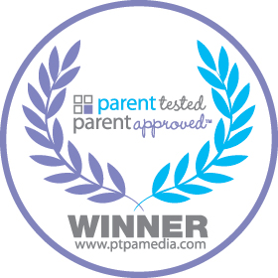

PTPA takes the guessing game out of shopping for your family, and when purchasing a product with this seal you can feel confident knowing that **other parents have tested and approved** of that product.

BettterAir has also applied for and anticipates shortly receiving endorsements from the Environmental Protection Agency, The American Asthma and Allergy Foundation, The US Green Building Council’s Green Seal certification along with Delos and Fitwell. We intend to continuously add endorsements and certifications for additional uses of Betterair.